Функциональные возможности языка Python.

Выполнил: Рабаданов Гаджимурад
Группа: ИУ5-33Б
Дата: 17.12.25г.
Описание задания:
lab_python_fp · ugapanyuk/BKIT_2022 Wiki · GitHub

Код программы:
1 Задание:

def field(items, *args):
assert len(args) > 0, "Должен быть хотя бы один ключ"

if len(args) == 1:
key = args[0]
for item in items:
value = item.get(key)
if value is not None:
yield value
else:
for item in items:
result = {key: item.get(key) for key in args if item.get(key) is not None}
if result:
yield result

if __name__ == "__main__":
goods = [
{'title': 'Ковер', 'price': 2000, 'color': 'green'},
{'title': 'Диван для отдыха', 'color': 'black'}
]

print(list(field(goods, 'title')))
print(list(field(goods, 'color')))
print(list(field(goods, 'title', 'price')))
2 Задание:
import random
def gen_random(count, min, max):
empty = None
if min > max:
empty = max
max = min
min = empty
for _ in range (count):
yield random.randint(min, max)

if __name__ == "__main__":
print(list(gen_random(4, 100, 1)))

3 Задание:
class Unique:
def __init__(self, items, **kwargs):
self.ignore_case = kwargs.get('ignore_case', False)
self.seen = set()
self.items = iter(items)

def __iter__(self):
return self

def __next__(self):
while True:
item = next(self.items)
comparison_item = item.lower() if self.ignore_case and isinstance(item, str) else item

if comparison_item not in self.seen:
self.seen.add(comparison_item)
return item
if __name__ == "__main__":
data = [1, 1, 1, 2, 2, 2, 3, 3]
for i in Unique(data):
print(i)
data = ['a', 'A', 'b', 'B', 'a', 'A', 'b', 'B']
for i in Unique(data):
print(i)
for i in Unique(data, ignore_case=True):
print(i)

4 Задание:
data = [4, -30, 100, -100, 123, 1, 0, -1, -4]

if __name__ == '__main__':
result = sorted(data, key = abs, reverse = True)
print(result)

result_with_lambda = sorted(data, key = lambda y: abs(y), reverse = False)
print(result_with_lambda)

5 Задание:
def print_result(func):
def printer(*args, **kwargs):
result = func(*args, **kwargs)

print(func.__name__)

if isinstance(result, list):
for item in result:
print(item)
elif isinstance(result, dict):
for key, value in result.items():
print(f"{key} = {value}")
else:
print(result)

return result
return printer

@print_result
def test_1():
return 1

@print_result
def test_2():
return 'iu5'

@print_result
def test_3():
return {'a': 1, 'b': 2}

@print_result
def test_4():
return [1, 2]

if __name__ == '__main__':
print('!!!!!!!!')
test_1()
test_2()
test_3()
test_4()

6 Задание:
import time
from contextlib import contextmanager

class cm_timer_1:
def __enter__(self):
self.start_time = time.time()
return self

def __exit__(self, exc_type, exc_val, exc_tb):
end_time = time.time()
print(f"time: {end_time - self.start_time:.2f}")
@contextmanager
def cm_timer_2():
start_time = time.time()
try:
yield
finally:
end_time = time.time()
print(f"time: {end_time - start_time:.2f}")
if __name__ == "__main__":
from time import sleep

print("Using cm_timer_1:")
with cm_timer_1():
sleep(2)
print("Using cm_timer_2:")
with cm_timer_2():
sleep(2)
7 Задание:
import json
import sys
import random
from contextlib import contextmanager
import time

def print_result(func):
def wrapper(*args, **kwargs):
result = func(*args, **kwargs)
print(func.__name__)
if isinstance(result, list):
for item in result:
print(item)
elif isinstance(result, dict):
for key, value in result.items():
print(f"{key} = {value}")
else:
print(result)
return result
return wrapper

class cm_timer_1:
def __enter__(self):
self.start_time = time.time()
return self

def __exit__(self, exc_type, exc_val, exc_tb):
end_time = time.time()
print(f"time: {end_time - self.start_time:.2f} seconds")

path = sys.argv[1] if len(sys.argv) > 1 else "data_light.json"
with open(path, encoding="utf-8") as f:
data = json.load(f)

@print_result
def f1(arg):
return sorted(set(job['job-name'].strip().lower().capitalize() for job in arg))

@print_result
def f2(arg):
return list(filter(lambda x: x.lower().startswith('программист'), arg))

@print_result
def f3(arg):
return list(map(lambda x: f"{x} с опытом Python", arg))

@print_result
def f4(arg):
salaries = [random.randint(100000, 200000) for _ in arg]
return [f"{job}, зарплата {salary} руб." for job, salary in zip(arg, salaries)]

if __name__ == '__main__':
with cm_timer_1():
f4(f3(f2(f1(data))))

Снимки экрана:
1 Задание:
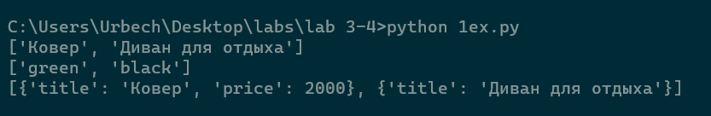
2 Задание:
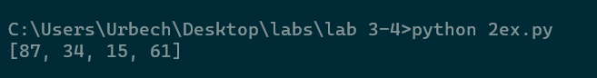
3 Задание:
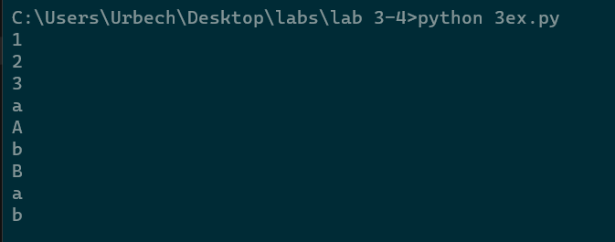
4 Задание:
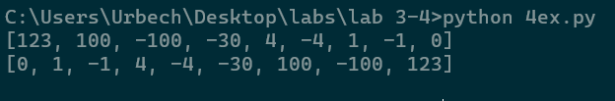
5 Задание:
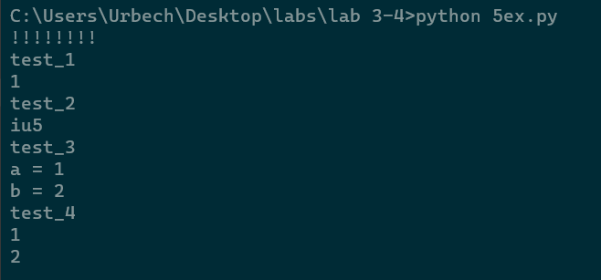
6 Задание:
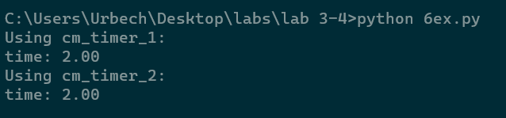
7 Задание:
